Experiment 4
Directory and File Display Commands
Aim
To execute ls, cat, and mkdir commands.

Output
ls Command
Lists files and directories.
Ls

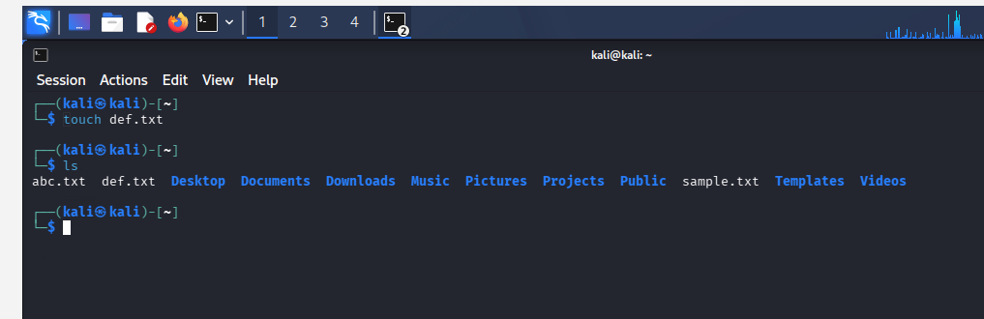

cat Command
Displays file contents.
cat file.txt

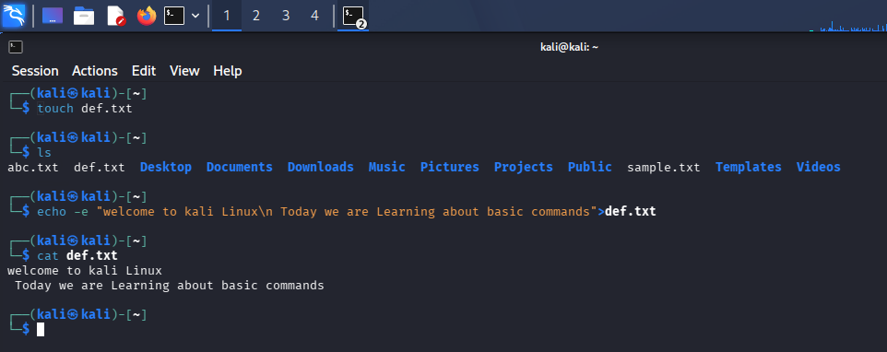

mkdir Command
Creates a new directory.
mkdir

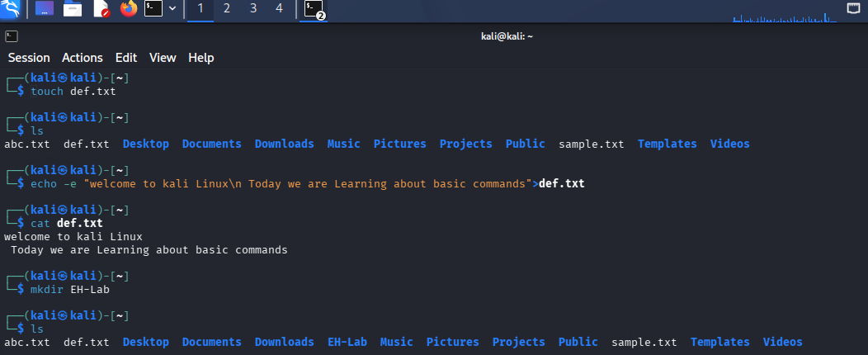

Result
Successfully executed ls, cat, and mkdir commands.

